Required Parental Consents

Day Care Provider:

Child's Name: Date of Birth: Parent's Name: Phone Number:

1. Release of Child:

416.8 (e) -No child can be released to any person other than a parent, a person designated in writing by parent, or other person authorized by law. No child can be released unsupervised except upon written instruction of the parent, and only when this is acceptable to the provider and considers such factors as child's age and maturity, proximity to child's home, and safety of the neighborhood



The following people have my permission to pick up my child from the provider's home:

Name: Relationship to Child:

Phone:

Name: Phone: _

Relationship to Child:

Name: Phone: Relationship to Child:

**Parent Signature: Date:

2 '’

1. Transportation Consent:

416.6 (a) -The provider must obtain written consent from the parent of the child for **any transportation** of **the children in care** at the group family day **care** home **provided or arranged for by a caregiver.**

**416.11 (f)(1)(ii)-Providers must** arrange for **the** transportation of **any** child in need of emergency health care, and for the supervision of the children remaining in the group family day care home

**///////////////////////////////////////////////////////////////////////////////////////////////////////////////////** I give permission for provider to transport my child in a vehicle for the following checked purposes:

* Field Trips
* Medical Emergency
* Other Explain:

The following guidelines must be followed while transporting my child:

* A caregiver or volunteer must never leave a child unattended in any motor vehicle or other form of transportation.
* Each child must board or leave a vehicle from the curb side of the street.
* All children must be secured in safety seats or by safety belts as appropriate for the age of the child in accordance with the requirements of the Vehicle and Traffic Law before any child may be transported in a motor vehicle where such transportation is provided or arranged for by the provider.
* Any motor vehicle, other than a public form of transportation, used to transport children in care at the family day care home must have a current registration and inspection sticker and must be operated by a person who is at least 18 years of age and possesses a valid driver's license.

**Parent Signature: Date:

1. **School-Age Supervision:**

**416.8 (a)(3)With the written** permission of the parents, providers may allow school- aged children to **participate in activities** outside of the direct supervision of a caregiver. Such activities must occur on the premises of the group family day care home. A caregiver must physically check such children every 15 minutes.



I give permissior. for my school-aged child to participate in activities outside the direct supervision of the caregiver. I understand that such activities must occur on the premises of the day care home, and that the provider will check on my child every 15 minutes.

**Parent Signature: Date:

3

1. Napping Arrangement: '"

416.8 (a)(1)With the prior written parental permission, children may nap or sleep in a room where an awake adult is not present. In these circumstances, the doors to all rooms must be open; the caregiver must remain on the same floor as the children, and a functioning electronic monitor must be used in any room where **children** are sleeping or napping and an awake adult is not present. Electronic monitors may be used as an indirect means of supervision only where the parents have agreed in advance to the use of such monitors, and only in situations where the children are sleeping. For evening and night care, the caregiver may sleep while the children are sleeping if the provider has obtained the written permission to do so from every parent of a child receiving evening or night care in the home. Without this written permission, the caregiver must remain awake at all times and physically check sleeping children every 15 minutes.

*1 /// //ffff/ff/ff////ffff/f/ffffff/ffffff/f//f//ff////f//fff/f/f//f/////ff/ff//f/f//ff/fff/fffff//f///f/ffffffff/fff/f/f//* I give permission for my child to take a nap or rest in the following area of the home: (Living room, Playroom, Bedroom)



I give permission for my child to sleep on the following:

Mat Cot Crib Bed

**Parent Signature: Date:

I give permission for my child to nap in a room that the caregiver is not present. I understand that the door must be left open, a caregiver will be on the same floor as my child, and the caregiver will check on my child every 15 minutes. Furthermore, I understand that a functioning electronic monitor must be used in any room where my child is sleeping and a caregiver is not present.

**Parent Signature: Date:

1. Topical Ointment Consent:

416.11 (j)(12)Over-the-counter topical ointments, including sunscreen lotion and topically applied insect repellant, may be administered by the provider upon the written instructions of the parent without the training in administration of medications otherwise required by regulation.

///////////////////////////////////////////////////////////////////////////////////////////////////////////////////////////// I give permission for caregiver to apply the following over-the-counter topical ointment to my child when needed:

Sunscreen: , Insect Repellent: , Diaper Cream: , Other: Comments:



**Parent Signature:

4

Date:

1. Infant Feeding Schedule

**416.11 (j)(13)(i)If an** infant requires over-the-counter topical ointment while in care at the program, such ointment may be given under verbal instructions from the parent for that day only if the instructions received from the parent are consistent with directions for use noted on the original container

* 1. **(j)(13)(ii)If a** child other than an infant requires over-the-counter medication, including topical ointments, while in care at the program, such medication or ointment may be given under verbal instructions from the parent for that day only if the instructions received are consistent with any directions for use noted on the original container.
  2. (i)Providers must obtain a written statement from the parent of each infant in care setting forth the formula and feeding schedule instructions for the infant.

I give permission for caregiver to mix formula for my child: I will provide caregiver with bottles of mixed formula:

I will provide caregiver with bottles of breast milk:

Feeding Instructions:

* + - Type (bottle, cereal, baby food)
    - Amount:
    - Time of Day or How Often:
    - Type (bottle, cereal, baby food)
    - Amount:
    - Time of Day or How Often:
    - Type (bottle, cereal, baby food)
    - Amount:
    - Time of Day or How Often:

Comments:



**Parent Signature: Date:

Authorization for Cons'ent to Medical Treatment of Minors

**416.11** (j)(7)(ii)Where **provider** has received **written authorization** to **administer** a specified medication if some specified condition or change of condition in the child is observed while the child is in care, the specified medication may be administered.

**416.11 (j)(10)Where medication is to be** given **on an ongoing, long-term** basis, the authorization and consent forms must be reauthorized at least once every six **months. Any changes in the original medication authorization require the provider** to obtain new written instructions written from the licensed prescriber as well as a change in the prescription

///////////////////////////////////////////////////////////////////////////////////////////////////////////////////////////////// New York State day care regulations require that all providers obtain written permission from each child's parent/guardian in the event emergency health care for a child is required and parent/guardian can not be reached.

In the event that the undersigned parent/guardian of

(Child's Name)

cannot be contacted through reasonable efforts, does hereby empower and grant to:

(Providers Name, Address, Phone)

the right to consent permission of an X-ray, examination, anesthetic, medical or surgical diagnosis, treatment and/or hospital care, to be rendered to the minor under the general or special supervision and on the advice of any physician or surgeon licensed to practice in the state of New York, when the need for such treatment is immediate and when efforts to contact me (us) are unsuccessful.

This authorization shall be valid for the period of time commencing on

and ending on

(Date)

(Signature of Parent/Guardian)

(Date)

(Date)

Information:

Parent/Guardian can be located at the following address/phone number during daycare hours:

(parent/guardian name, address, phone)

(parent/guardian name, address, phone)

Any known allergies: Child's Physician: Phone:

Insurance Company: Policy #:

NEW YORK STATE

OFFICE OF CHILDREN AND FAMILY SERVICES

Medical Statement of Child in Childcare

**To Be Completed By Licensed Physician, Physician's Assistant or Nurse Practitioner**

Name of Child:

Date of Birth:

Date of Examination:

**Immunizations required for entry into day** care

Medical Exemption The physical condition of the named child is such that one or more of the immunizations would endanger life or health. Attach certification specifying the exempt immunization(s).

Q Yes No

|  |  |  |  |  |  |  |  |
| --- | --- | --- | --- | --- | --- | --- | --- |
| Diphtheria, Tetanus and Pertussis (DPT) Diphtheria and Tetanus and acellular Pertussis (DTaP) | 1° | Date | 2"° Date | | 3* Date | 4" Date | 5” Date |
| Polio (IPV or OPV} | 1‘ | Date | 2’° Date | | 3* Date | 4” Date |  |
| Haemophilus influenzae type B (Hib) | 1" | Date | 2 | Date | 3" Date | 4” Date OR 1‘ Date (if given on or after 15 months of age) | |
| Pnuemococcal Conjugate | 1‘ | Date | 2’^ Date | | 3* Date | 4” Date | |
| (PCV) for those born on or |  | |
|  | |  |  | |
| after 1/1/08) |  | |  | |  |  | |
| Hepatitis B | 1" | Date | 2"° Date | | 3* Date |  | |
| Measles, Mumps and | 1" | Date | 2 | Date |  |  | |
| Rubella (MMR) |  | |  | |  |  | |
| Varicella (also known as | 1‘ | Date | 2’° Date | |  |  | |
| Chicken Pox) |  | |  | |  |  | |

**Other Immunizations may include the recommended vaccines of Rotavirus, Influenza and Hepatitis A**

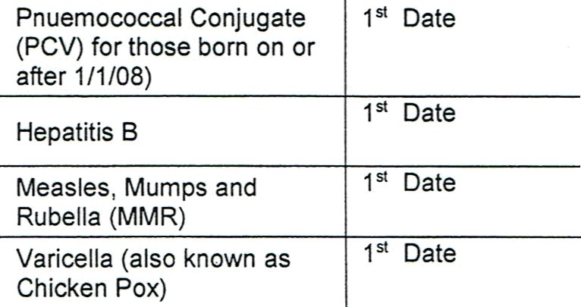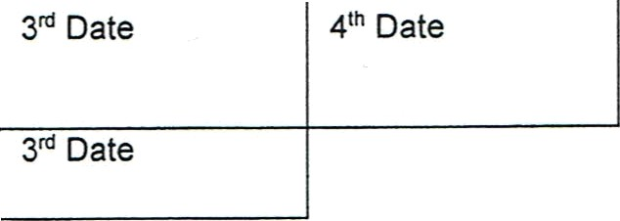

|  |  |  |  |
| --- | --- | --- | --- |
| Type of Immunization: | Date: | Type of Immunization: | Date: |
| Type of Immunization: | Date: | Type of Immunization: | Date: |
| Type of Immunization: | Date: | Type of Immunization: | Date: |

**Tests**

Tuberculin Test Date:

/ /

Mantoux Results: @ Positive @ Negative

mm

TB Tests are at the physician's discretion.

If positive, or if x-ray ordered, attach physician's statement documenting treatment and follow-up.

Lead Screening Date: / / Attach lead level statement

Lead Screening (Include All Dates and Results)

1 year / / Result:

2 years / / Result:

mcg/dL

mcg/dL

D Venous

@ Venous

@ Capillary

@ Capillary

**Most** recent **date of lead screening (if different from** above):

/ / Result: mCg/dL @ Venous @ Capillary

Per NYS law, a blood lead **test is required at** 1 and **2 years** of **age and whenever risk of lead poisoning is likely.** If the child has not been tested for lead, the day care provider may not exclude the child from child day care, but must give the parent information on lead poisoning and prevention, and refer the parent to their health care provider or the county health department for a lead blood screening test.

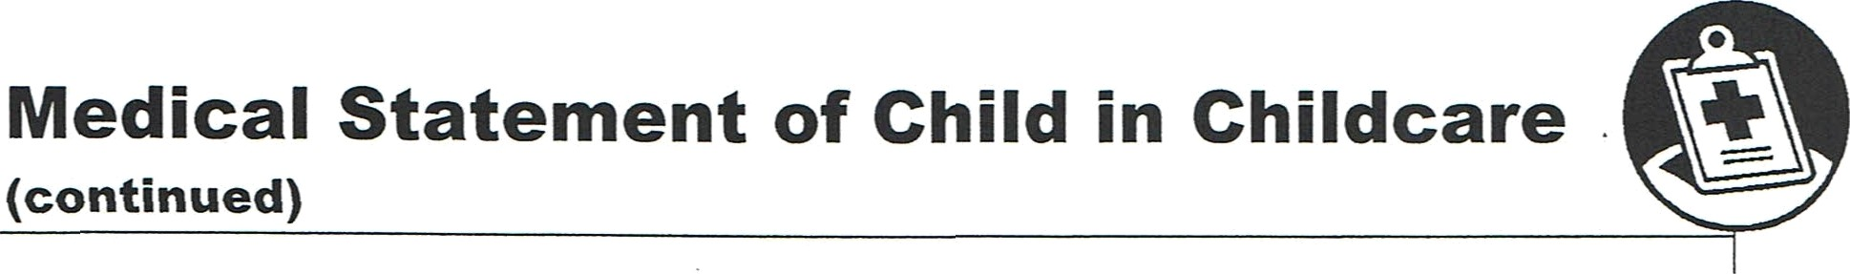

Medical Statement of Child in Childcare

(continued)

@

**Health Specifics** Comments

|  |  |  |  |  |  |
| --- | --- | --- | --- | --- | --- |
| Are there allergies? (Specify) |  | Yes |  | No |  |
|  |
| Is medication regularly taken? (Specify drug and condition) | Q | Yes | Q | No |  |
|  |
| Is a special diet required? (Specify diet and condition) |  | Yes | @ | No |  |
|  |
| Are there any hearing, visual or dental conditions requiring special attention? |  | Yes | Q | No |  |
|  |
| Are there any medical or developmental conditions requiring special attention? |  | Yes | @ | No |  |
|  |

**Summary of Physical Exam**

Include special recommendations to Day Care Providers











On the basis of my findings as indicated above and on my knowledge of the named child, I find

that: he/she is free from contagious and communicable disease and is able to participate in day a Yes No

care.

Signature of Examiner

Please Print Name

Address

City, State, Zip

()

Title

Phone

Date

**Religious Exemptions**

Public Health law Section 2164 allows a child to be religiously exempted from immunization. A written and signed statement from a parent, parents or guardian of the child stating that they object of the immunization of their child due to their sincere and genuine religious beliefs should be submitted to the day care owner, operator or administrator who shall determine whether the statement of religious belief is acceptable.